Fork a repository from github

1. Create a empty folder. I have created a folder named git . Now move to that directory by using command “cd git”

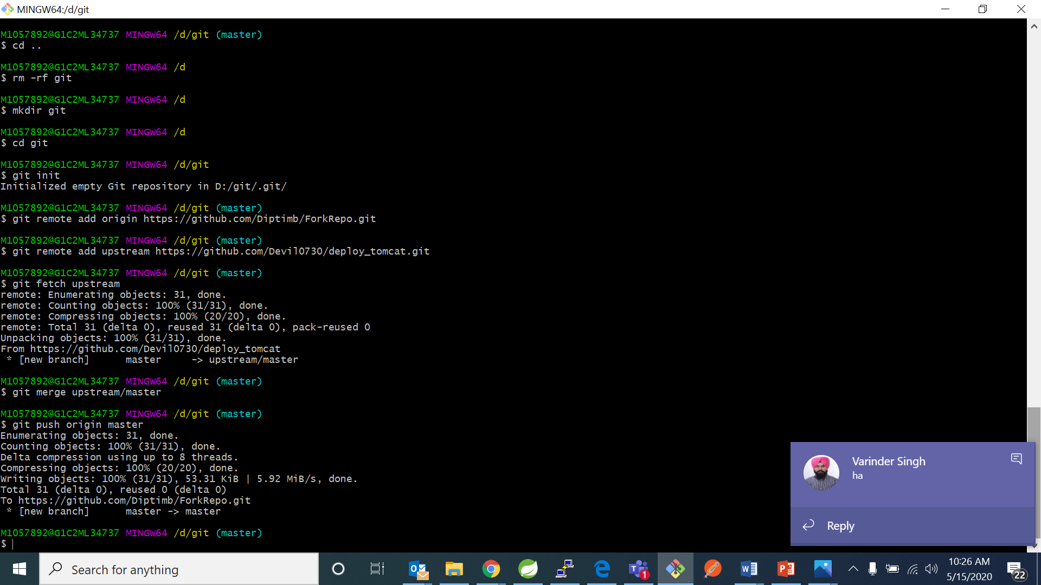

1. Now initialize git repository in your local folder by using command “git init”



1. Now add your git hub repository as origin using the command:

“git remote add origin https://github.com/Diptimb/ForkRepo.git”



1. Now add the repository from where you want to fork. I am using my friend’s repository for forking. Use the command

“get remote add upstream https://github.com/Devi0730/deploy_tomcat.git”



1. Now fetch from the upstream repository by using command “git fetch upstream”. It will load the files from the upstream repository.



1. In your local check if all the files are downloaded in your local repository or not using command “ls –al”

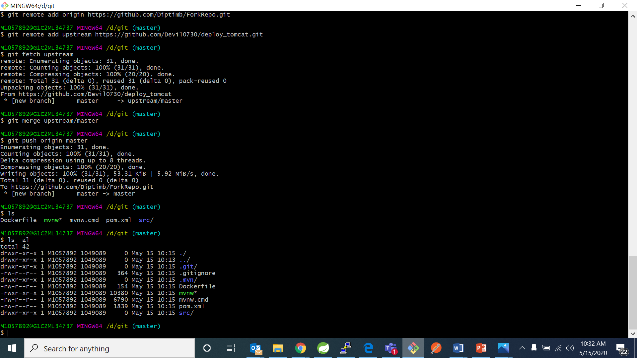

1. Now merge the upstream with your master branch using command “git merge upstream/master”.



1. Now push the files in your local to your github using the command “git push origin master”



1. Now open your github account and open your repository and check if the upstream files has been forked into your account or not.

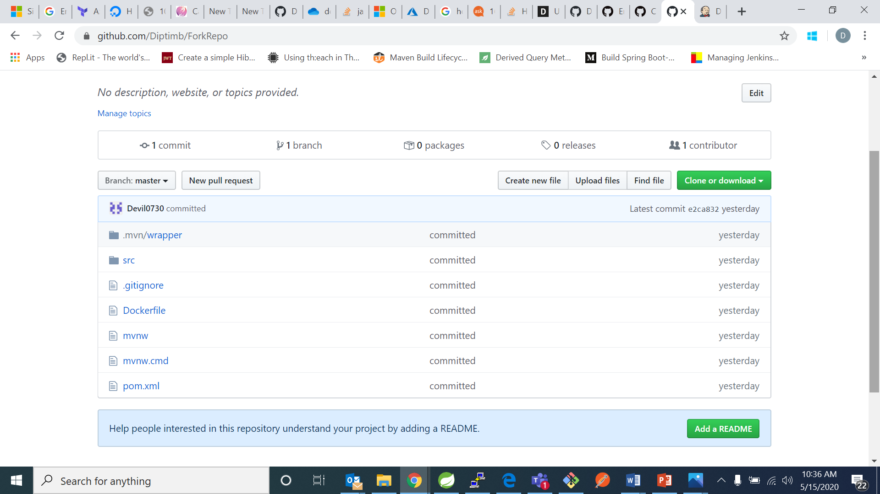

Here I can see that the upstream repository has been forked and it is also mentioned that from it has been forked.